ABSTRACT
Over the past few decades, cardiovascular diseases have surpassed all other causes of death as the main killers in industrialised, underdeveloped, and developing nations. Early detection of heart conditions and clinical care can lower the death rate. Based on the patient's various cardiac features, we proposed a model for forecasting heart disease and identifying impending heart disease using machine learning techniques such logistic regression, SVM, Multinomial Nave Bayes, Random Forest, and Decision Tree. In most cases, input is received through numerical data of various parameters, and output findings are generated in real-time, predicting whether or not the patient has a disease. We'll use a variety of supervised machine learning methods before deciding which one is best for the model. Existing systems rely on classical deep learning models, which are inefficient and imprecise. They aren't as accurate as the proposed model and take a little longer to process.

CHAPTER - 1
INTRODUCTION
1.1 Introduction
Cardio Vascular Disease (CVD) is the most well-known perilous infection around the world: the greater part of the populaces bites the dust every year from Cardio Vascular Disease (CVD) than from some other ailment. A degree of 17.9 million individuals passed on from Cardio Vascular Disease (CVD) in , thinking about 31% of every single worldwide demise. Of these deaths, 85% are because of heart stroke and heart failure. More than three-fourths of CVD deaths occur in dejected yield nations. Out of the 17 million less than ideal closures (younger than 70) due to noninfectious maladies in 2015, 82% are in discouraging yield nations and 37% are brought about via Cardio Vascular Disease(CVD). All most Cardio Vascular Disease(CVD) can be killed by tending to discernible hazard factors, for example, tobacco use, undesirable eating routine and heftiness, physical dormancy and destructive utilization of liquor utilizing populace wide situations.
Individuals with Cardio Vascular Disease(CVD) or who are at high cardiovascular hazards (because of the nearness of at least one hazard factor, for example, hypertension, diabetes, hyperlipidemia or effectively settled sickness) need an early introduction and directorate utilizing brief prescriptions, as set apart. All in all, Cardio Vascular Disease (CVD) is winded up with a development of greasy stores inside the conduits (atherosclories) and development of blood clusters.
It can likewise be related to harm to courses in organs, for example, the mind, heart, kidneys, and eyes. CVD is one of the fundamental drivers of death and incapacity in the UK, however, it can regularly to a great extent be avoided by driving a solid way of life. Coronary episodes and strokes are typically brought about by intense occasions and are for the most part brought about by a blockage that averts bloodstream to the heart or mind.
The most widely recognized purpose behind this is the development of greasy stores most inward dividers of veins. The reason for cardiovascular failures and strokes is generally the nearness of a blend of hazard factors, for example, tobacco use, unfortunate eating regimen, and heftiness.
The work proposed in this project focus mainly on various data mining practices that are employed in heart stroke Prediction. Human heart is the principal part of the human body. Any irregularity to heart can cause distress in other parts of body. In today’s contemporary world, heart stroke is one of the primary reasons for occurrence of most deaths. Heart stroke may occur due to unhealthy lifestyle, smoking, alcohol and high intake of fat which may cause hyper-tension . According to the World Health Organization more than 10 million die due to Heart stroke every single year around the world. A healthy lifestyle and earliest detection are only ways to prevent the heart stroke. The main challenge in today's healthcare is provision of best quality services and effective accurate diagnosis .

The proposed work makes an attempt to detect these heart stroke at early stage to avoid disastrous consequences. Data mining techniques are the means of extracting valuable and hidden information from the large amount of data available. Machine Learning (ML) which is subfield of data mining handles large scale well-formatted dataset efficiently. In the medical field, machine learning can be used for diagnosis, detection and prediction of various diseases. The main goal of this project is to provide a tool for doctors to detect heart stroke as early stage . This in turn will help to provide effective treatment to patients and avoid severe consequences. ML plays a very important role to detect the hidden discrete patterns and thereby analyze the given data. After analysis of data ML techniques help in heart stroke prediction and early diagnosis. This project presents performance analysis of various ML techniques such as KNN, Decision Tree, and Random Forest for predicting heart stroke at an early stage.

1.2 Problem statement
A lot of work has been done for identifying heart diseases, for this project we have gone through. in reference [6] Pearson, Kendall, Spearman correlation are explained, to determine which independent attribute is proportional or inversely proportional to dependent attribute also how much it is correlated with correlation value if equal to 1 it is highly correlated and proportional while if equal to -1 it is highly correlated and inversely proportional if it is 0 meaning no correlation, we have applied correlation and found some attribute is positive while some are negatively correlated with the target value. Also in three of them, Spearman correlation gave the best value of the correlation factor. In reference [7] They used ROC to compare the result of various classifiers, the abbreviation ROC stands for Receiver Operating Characteristic.
1.3 Objectives
With the increasing number of deaths due to heart stroke’s, it has become mandatory to develop a system to predict heart stroke effectively and accurately. The motivation for the study was to find the most efficient ML algorithm for detection of heart stroke. This study compares the accuracy score of Random Forest, Decision Tree and KNN algorithms for predicting heart stroke using kaggle dataset. The result of this study indicates that the Random Forest algorithm is the most efficient algorithm with accuracy score of 99.17% for prediction of heart stroke. In future the work can be enhanced by developing a web application based on the Random Forest algorithm as well as using a larger dataset as compared to the one used in this analysis which will help to provide better results and help health professionals in predicting the heart disease effectively and efficiently

CHAPTER – 2
LITERATURE SURVEY

1) Comparison Of Machine Learning Algorithms For Clinical Event Prediction (Risk Of Coronary Heart Disease)
AUTHORS: Beunza, Juan-Jose
The aim of this study is to compare the utility of several supervised machine learning (ML) algorithms for predicting clinical events in terms of their internal validity and accuracy. The results, which were obtained using two statistical software platforms, were also compared.The data used in this research come from the open database of the Framingham Heart Study, which originated in 1948 in Framingham, Massachusetts as a prospective study of risk factors for cardiovascular disease. Through data mining processes, three data models were elaborated and a comparative methodological study between the different ML algorithms – decision tree, random forest, support vector machines, neural networks, and logistic regression – was carried out. The global selection criterium for choosing the right set of hyperparameters and the type of data manipulation was the area under a curve (AUC).

2) Enhancing Detection Accuracy for Clinical Heart Failure Utilizing Pulse Transit Time Variability and Machine Learning
AUTHORS: Zhao, Lina
Physiological signal variability can offer important insight into cardiovascular activity and clinical cardiovascular diseases. Heart rate variability (HRV) and pulse transit time variability (PTTV) are two important time series variabilities. However, combining HRV and PTTV can enhance the classification accuracy for heart failure which is unknown. In this project, a simultaneous analysis of HRV and PTTV performed on both normal subjects and heart failure patients, was carried out, aiming to investigate the improvement of HRV-based heart failure detection with the assistant of PTTV analysis. Forty normal subjects and forty heart failure patients were enrolled. Standard limb lead-II electrocardiogram and radial artery pressure waveforms were synchronously recorded. HRV and PTTV analysis were performed on the acquired RR and PTT time series using the standard time- (MEAN, SDNN, and RMSSD), frequency- (LF, HF, and LF/HF), and non-linear (SD1, SD2, sample entropy, and fuzzy measure entropy) domain indices. The results showed that all HRV indices except MEAN (P = 0.1) and LF/HF (P = 0.9) showed significant differences (all P <;0.01) between the two group, while only MEAN in PTTV significantly decreases in heart failure patients (P <; 0.01). Moreover, when combined the HRV, PTTV indices, and the predicted probabilities generated from the distance distribution matrix-based convolutional neural network models, the highest classification performances were achieved by a support vector machine classifier, outputting a sensitivity of 0.93, a specificity of 0.88, and an accuracy of 0.90. This project demonstrated the potential of PTTV analysis for the detection of clinical heart failure.

3) Using Machine Learning to Predict One-year Cardiovascular Events in Patients with Severe Dilated Cardiomyopathy
AUTHORS : Chen, Rui

Dilated cardiomyopathy (DCM) is a common form of cardiomyopathy and it is associated with poor outcomes. A poor prognosis of DCM patients with low ejection fraction has been noted in the short-term follow-up. Machine learning (ML) could aid clinicians in risk stratification and patient management after considering the correlation between numerous features and the outcomes. The present study aimed to predict the 1-year cardiovascular events in patients with severe DCM using ML, and aid clinicians in risk stratification and patient management.

The dataset used to establish the ML model was obtained from 98 patients with severe DCM (LVEF < 35%) from two centres. Totally 32 features from clinical data were input to the ML algorithm, and the significant features highly relevant to the cardiovascular events were selected by Information gain (IG). A naive Bayes classifier was built, and its predictive performance was evaluated using the area under the curve (AUC) of the receiver operating characteristics by 10-fold cross-validation.

4) A Novel Ontology And Machine Learning Driven Hybrid Cardiovascular Clinical Prognosis As A Complex Adaptive Clinical System.
AUTHORS : Farooq, Kamran, and Amir Hussain
This multidisciplinary industrial research project sets out to develop a hybrid clinical decision support mechanism (inspired by ontology and machine learning driven techniques) by combining evidence, extrapolated through legacy patient data to facilitate cardiovascular preventative care. The proposed cardiovascular clinical decision support framework comprises of two novel key components: (1) Ontology driven clinical risk assessment and recommendation system (ODCRARS) (2) Machine learning driven prognostic system (MLDPS). State of the art machine learning and feature selection methods are utilised for the prognostic modelling purposes. The ODCRARS is a knowledge-based system which is based on clinical expert’s knowledge, encoded in the form of clinical rules engine to carry out cardiac risk assessment for various cardiovascular diseases. The MLDPS is a non knowledge-based/data driven system which is developed using state of the art machine learning and feature selection techniques applied on real patient datasets. Clinical case studies in the RACPC, heart disease and breast cancer domains are considered for the development and clinical validation purposes. For the purpose of this project, clinical case study in the RACPC/chest pain domain will be discussed in detail from the development and vaidation perspective. The proposed clinical decision support framework is validated through clinical case studies in the cardiovascular domain. This project demonstrates an effective cardiovascular decision support mechanism for handling inaccuracies in the clinical risk assessment of chest pain patients and help clinicians effectively distinguish acute angina/cardiac chest pain patients from those with other causes of chest pain. The new clinical models, having been evaluated in clinical practice, resulted in very good predictive power, demonstrating general performance improvement over benchmark multivariate statistical classifiers. Various chest pain risk assessment prototypes have been developed and deployed online for further clinical trials.

5) A Real-time Arrhythmia Heartbeats Classification Algorithm using Parallel Delta Modulations and Rotated Linear-Kernel Support Vector Machines
AUTHORS: Tang, Xiaochen
Real-time wearable electrocardiogram monitoring sensor is one of the best candidates in assisting cardiovascular disease diagnosis. In this project, we present a novel real-time machine learning system for Arrhythmia classification. The system is based on the parallel Delta modulation and QRS/PT wave detection algorithms. We propose a patient dependent rotated linear-kernel support vector machine classifier that combines the global and local classifiers, with three types of feature vectors extracted directly from the Delta modulated bit-streams. The performance of the proposed system is evaluated using the MIT-BIH Arrhythmia database. According to the AAMI standard, two binary classifications are performed and evaluated, which are supraventricular ectopic beat (SVEB) versus the rest four classes, and ventricular ectopic beat (VEB) versus the rest. For SVEB classification, the preferred SkP-32 method's F1 score, sensitivity, specificity, and positive predictivity value are 0.83, 79.3%, 99.6%, and 88.2%, respectively, and for VEB classification, the numbers are 0.92%, 92.8%, 99.4%, and 91.6%, respectively. The results show that the performance of our proposed approach is comparable to that of published research. The proposed low-complexity algorithm has the potential to be implemented as an on-sensor machine learning solution.

CHAPTER – 3
SYSTEM ANALYSIS
3.1 EXISTING SYSTEM:
Cosmology and machine learning for visualizing cardio vascular disease as a complex versatile clinical framework. Ontology and machine learning are the techniques that have been utilized in existing methodology. Therefore, it shows a viable cardiovascular choice to help instrument for taking care of mistakes in the clinical hazard appraisal of chest torment patients and helps clinicians adequately recognize intense angina/heart chest torment patients from those with different reasons for chest torments. Another machine learning procedure is Coronary Artery Disease method called N2 Genetic optimizer agent (another hereditary preparing) has been presented in this methodology. These outcomes are aggressive and practically identical to the best outcomes in the field.
DISADVANTAGES OF EXISTING SYSTEM:
- Machine learning-based coronary artery disease examined datasets, test sizes, highlights, areas of information accumulation, execution measurements, and applied ML are the basic methods that have been broken down in this methodology.
- Chronic Heart Failure Detection is an anticipated the Constant Cardiovascular breakdown identification from heart sounds utilizing a pile of machine learning classifiers. The strategies used to foresee comprises filtering segmentation and feature extraction to the model.
Algorithm: Cardiovascular Infection Expectation Framework, Genetic algorithm.
3.2 PROPOSED SYSTEM:
We worked on heart disease dataset obtained from UCI (University of California at Irvine) repository, the data set contained attributes such as age, sex, cp, trestbps, cho, fbs, restecg, thalach, ca, and target with 304 instances has taken. At first level, The dataset is first cleansed and processed using preprocessing techniques like Data Integration, Data transformation, Data reduction, and Data cleaning using pandas tool. The proposed framework a total of 304 patient records were visualized. Data visualization techniques helps the data scientist to understand the feasibility of the dataset. The box plot relationship between the sex and target attributes. The correlation matrix and histogram were represented.
ADVANTAGES OF PROPOSED SYSTEM:
- The accuracy of the classifiers was calculated using the confusion matrix.
- The classifier which bags up the highest accuracy could be determined as the best classifier.
Algorithm: Support Vector Machine (SVM), Decision Tree (DT), Random Forest (RF), K-Nearest Neighbors (KNN).

3.3 Project Requirements
The project involved analyzing the design of few applications so as to make the application more users friendly. To do so, it was really important to keep the navigations from one screen to the other well ordered and at the same time reducing the amount of typing the user needs to do. In order to make the application more accessible, the browser version had to be chosen so that it is compatible with most of the Browsers.
Functional Requirements
- Graphical User interface with the User.
Non Functional Requirements
• Maintainability: Maintainability is used to make future maintenance easier, meet new requirements. Our project can support expansion.
• Robustness: Robustness is the quality of being able to withstand stress, pressures or changes in procedure or circumstance. Our project also provides it.
• Reliability: Reliability is an ability of a person or system to perform and maintain its functions in circumstances. Our project also provides it.
• Size: The size of a particular application plays a major role, if the size is less then efficiency will be high. The size of database we have developed is 5.05 MB.
• Speed: If the speed is high then it is good. Since the no of lines in our code is less, hence the speed is high.
• Power Consumption: In battery-powered systems, power consumption is very important. In the requirement stage, power can be specified in terms of battery life.
However the allowable wattage can’t be defined by the customer. Since the no of lines
of code is less CPU uses less time to execute hence power usage will be less.

Hardware Requirements
- System : Pentium IV 2.4 GHz.
- Hard Disk : 40 GB.
- Floppy Drive : 1.44 Mb.
- Monitor : 14’ Colour Monitor.
- Mouse : Optical Mouse.
- Ram : 512 Mb.
Software Requirements
- Operating system : Windows 7 Ultimate.
- Coding Language : Python.
- Front-End : Python.

Numpy
Python has a strong set of data types and data structures. Yet it wasn’t designed for MachineLearning per say. Enter numpy (pronounced as num-pee). Numpy is a data handling library,particularly one which allows us to handle large multi-dimensional arrays along with a hugecollectionofmathematical operations.Thefollowingis aquick snippetofnumpyin action.
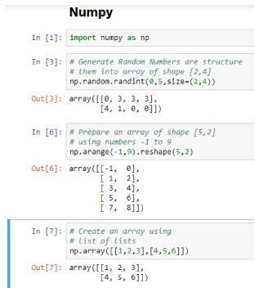
Numpy isn’t just a data handling library known for its capability to handle multidimensionaldata. It is also known for its speed of execution and vectorization capabilities. It providesMATLABstylefunctionalityandhencerequiressomelearningbeforeyoucangetcomfortable.It is also a core dependency for other majorly used libraries like pandas, matplotlib and so on.It’sdocumentation itselfis a good startingpoint.

Pandas
Think of relational data, think pandas. Yes, pandas is a python library that provides flexibleand expressive data structures (like dataframes and series) for data manipulation. Built on topofnumpy, pandas is as fast andyeteasierto use.

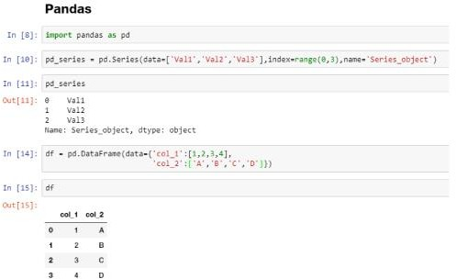

Pandas provides capabilities to read and write data from different sources like CSVs, Excel,SQL Databases, HDFS and many more. It provides functionality to add, update and deletecolumns, combine or split dataframes/series, handle datetime objects, impute null/missingvalues, handle time series data, conversion to and from numpy objects and so on. If you areworking on a real-world Machine Learning use case, chances are, you would need pandassooner than later. Similar to numpy, pandas is also an important component of the SciPy orScientificPython Stack .
Scipy
Pronounced as Sigh-Pie, this is one of the most important python libraries of all time. Scipy isa scientific computing library for python. It is also built on top of numpy and is a part of theScipyStack.
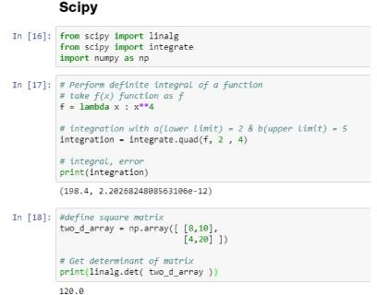

Thisisyetanotherbehindthesceneslibrarywhichdoesawholelotofheavylifting.Itprovidesmodules/algorithmsforlinearalgebra,integration,imageprocessing,optimizations,clustering,sparsematrixmanipulation and manymore..

Matplotlib
AnothercomponentoftheSciPystack,matplotlibisessentiallyavisualizationlibrary.Itworksseamlesslywithnumpyobjects(anditshigh-levelderivativeslikepandas).Matplotlibprovidesa MATLAB like plotting environment to prepare high-quality figures/charts for publications,notebooks,web applications and so on.
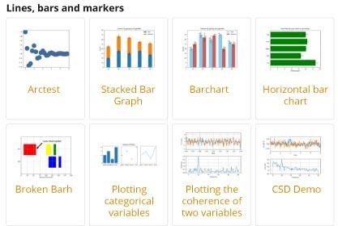

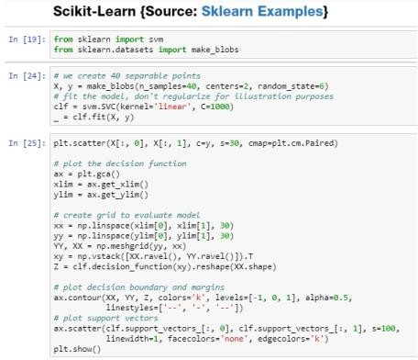
Matplolib is a high customizable low-level library that provides a whole lot of controls andknobstoprepareanytypeofvisualization/figure.Givenitslow-levelnature,itrequiresabitofgettingusedto alongwithplentyofcodetogetstuffdone.Its welldocumentedandextensibledesignhasallowedawholelistofhigh-levelvisualizationlibrariestobebuiltontop.Someofwhich,wewill discuss in the comingsections.:

Scikit-Learn
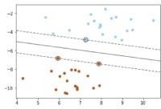
Designed as an extension to the SciPy library, scikit-learn has become the de-facto standardformanyofthemachinelearningtasks.DevelopedaspartofGoogleSummerofCodeproject,ithas now become awidely contributed open source project with over 1000contributors.

Scikit-learn provides a simple yet powerful fit-transform and predict paradigm to learn from data, transform the data and finally predict. Using this interface, it provides capabilities to prepare classification, regression, clustering and ensemble models. It also provides a multitude of utilities for preprocessing, metrics, model evaluation techniques, etc.

Visualization
Seaborn
Built on top of matplotlib, seaborn is a high level visualization library. It provides so phisticated styles straight out of the box (which would take some good amount of effort if done using matplotlib).
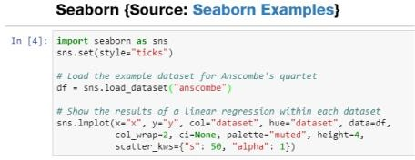
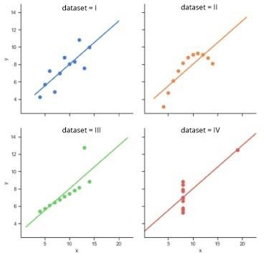

CHAPTER – 4
SYSTEM DESIGN
System Architecture
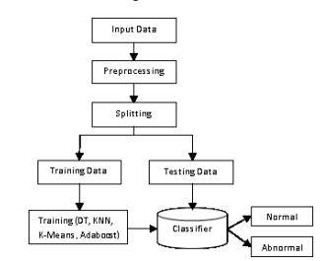
The proposed work predicts heart stroke by exploring the above mentioned four classification algorithms and does performance analysis. The objective of this study is to effectively predict if the patient suffers from heart stroke. The health professional enters the input values from the patient's health report. The data is fed into model which predicts the probability of having heart stroke. Fig. 1 shows the entire process involved. This study aims to predict the probability of heart disease through computerized heart disease prediction, which can be beneficial for medical professionals and patients. To achieve this objective, we employed various machine learning algorithms on a dataset and present the results in this study report. To enhance the methodology, we plan to clean the data, eliminate irrelevant information, and incorporate additional features such as MAP and BMI. Next, we will separate the dataset based on gender and implement k-modes clustering. Finally, we will train the model with the processed data. The improved methodology will produce more accurate results and superior model performance, as demonstrated.

It is feasible to increase model performance and save a considerable amount of runtime by selecting the ideal subset of features that have a significant impact on the prediction outcomes. This process is referred to as feature selection, and it is possible to accomplish both of these goals.
The three most common methods for picking characteristics are called filters, wrappers, and embedding. The research we conducted utilised the embedded approach known as GBDT as a means of selecting feature variables. This was due to the fact that embedded techniques offer superior prediction performance compared to filter methods and are noticeably quicker than wrapper methods.
GBDT makes use of an additive model and a forward stepwise algorithm in order to achieve learning. These two components work together to accomplish this. For non-leaf nodes, the significance of the features increases proportionately with the magnitude of the reduction in weighted impurity that occurs during splitting.
BLOCK DIGARAM
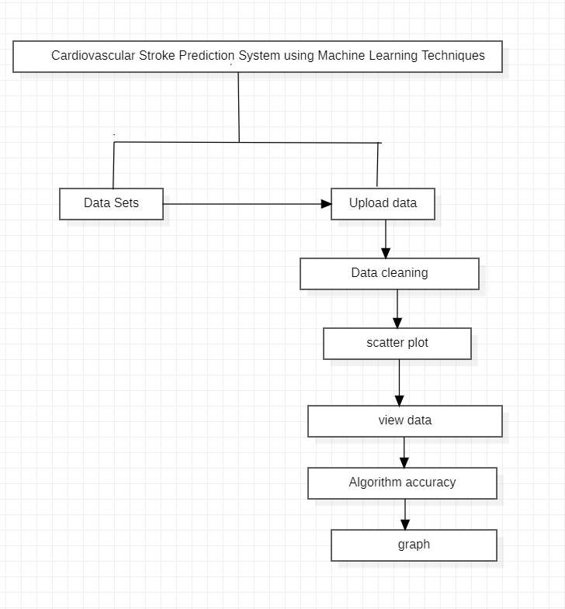
This is the detailed representation of project
DATA FLOW DIAGRAM:
1. The DFD is also called as bubble chart. It is a simple graphical formalism that can be used to represent a system in terms of input data to the system, various processing carried out on this data, and the output data is generated by this system.
2. The data flow diagram (DFD) is one of the most important modeling tools. It is used to model the system components. These components are the system process, the data used by the process, an external entity that interacts with the system and the information flows in the system.
3. DFD shows how the information moves through the system and how it is modified by a series of transformations. It is a graphical technique that depicts information flow and the transformations that are applied as data moves from input to output.
4. DFD is also known as bubble chart. A DFD may be used to represent a system at any level of abstraction. DFD may be partitioned into levels that represent increasing information flow and functional detail
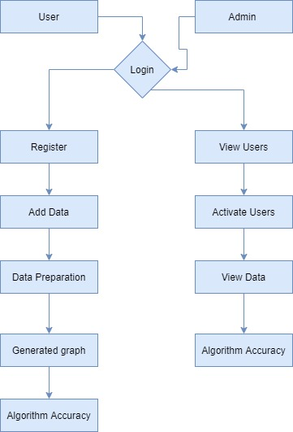
UML Diagrams
UML stands for Unified Modeling Language. UML is a standardized general-purpose modeling language in the field of object-oriented software engineering. The standard is managed, and was created by, the Object Management Group.
The goal is for UML to become a common language for creating models of object oriented computer software. In its current form UML is comprised of two major components: a Meta-model and a notation. In the future, some form of method or process may also be added to; or associated with, UML.
The Unified Modeling Language is a standard language for specifying, Visualization, Constructing and documenting the artifacts of software system, as well as for business modeling and other non-software systems.
The UML represents a collection of best engineering practices that have proven successful in the modeling of large and complex systems.
The UML is a very important part of developing objects oriented software and the software development process. The UML uses mostly graphical notations to express the design of software projects.

GOALS:
The Primary goals in the design of the UML are as follows:
- Provide users a ready-to-use, expressive visual modeling Language so that they can develop and exchange meaningful models.
- Provide extendibility and specialization mechanisms to extend the core concepts.
- Be independent of particular programming languages and development process.
- Provide a formal basis for understanding the modeling language.
- Encourage the growth of OO tools market.
- Support higher level development concepts such as collaborations, frameworks, patterns and components.
7. Integrate best practices.

CLASS DIAGRAM
In software engineering, a class diagram in the Unified Modeling Language (UML) is a type of static structure diagram that describes the structure of a system by showing the system's classes, their attributes, operations (or methods), and the relationships among the classes. It explains which class contains information.

USE CASE DIAGRAM
A use case diagram in the Unified Modeling Language (UML) is a type of behavioral diagram defined by and created from a Use-case analysis. Its purpose is to present a graphical overview of the functionality provided by a system in terms of actors, their goals (represented as use cases), and any dependencies between those use cases. The main purpose of a use case diagram is to show what system functions are performed for which actor. Roles of the actors in the system can be depicted.

SEQUENCE DIAGRAM
A sequence diagram in Unified Modeling Language (UML) is a kind of interaction diagram that shows how processes operate with one another and in what order. It is a construct of a Message Sequence Chart. Sequence diagrams are sometimes called event diagrams, event scenarios, and timing diagrams.

Collaboration diagram:
A collaboration diagram groups together the interactions between different objects. The interactions are listed as numbered interactions that help to trace the sequence of the interactions. The collaboration diagram helps to identify all the possible interactions that each object has with other objects.
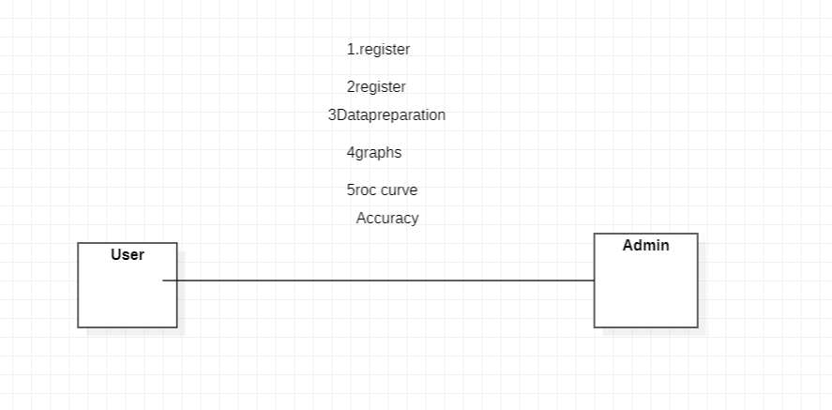

ACTIVITY DIAGRAM:
Activity diagrams are graphical representations of workflows of stepwise activities and actions with support for choice, iteration and concurrency. In the Unified Modeling Language, activity diagrams can be used to describe the business and operational step-by-step workflows of components in a system. An activity diagram shows the overall flow of control.

State diagram:
A state diagram, as the name suggests, represents the different states that objects in the system undergo during their life cycle. Objects in the system change states in response to events. In addition to this, a state diagram also captures the transition of the object's state from an initial state to a final state in response to events affecting the system.
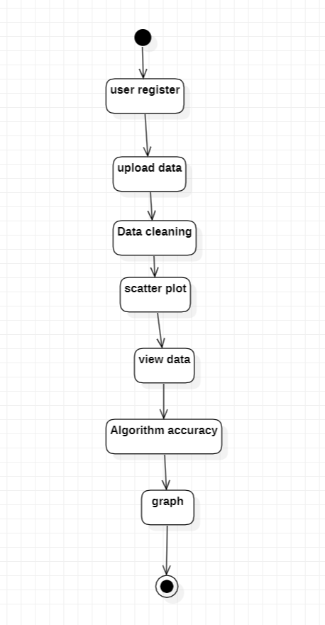

Object diagram:
The object diagram is a special kind of class diagram. An object is an instance of a class. This essentially means that an object represents the state of a class at a given point of time while the system is running. The object diagram captures the state of different classes in the system and their relationships or associations at a given point of time.
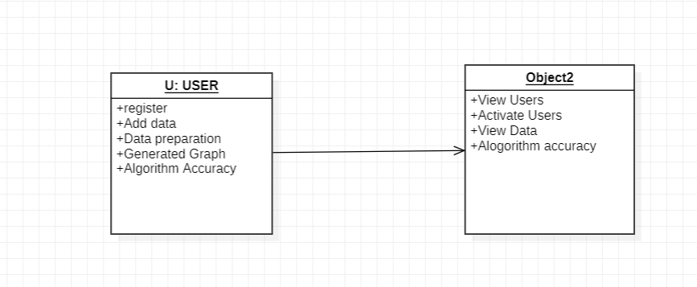

ALGORITHM
K-Nearest Neighbors Algorithm?
K-Nearest Neighbours is one of the most basic yet essential classification algorithms in Machine Learning. It belongs to the supervised learning domain and finds intense application in pattern recognition, data mining, and intrusion detection.
It is widely disposable in real-life scenarios since it is non-parametric, meaning, it does not make any underlying assumptions about the distribution of data (as opposed to other algorithms such as GMM, which assume a Gaussian distribution of the given data). We are given some prior data (also called training data), which classifies coordinates into groups identified by an attribute.
As an example, consider the following table of data points containing two features:
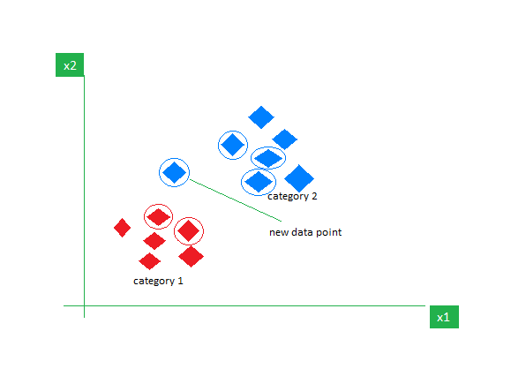

Now, given another set of data points (also called testing data), allocate these points to a group by analyzing the training set. Note that the unclassified points are marked as ‘White’.

Logistic regression

Logistic regression is a supervised machine learning algorithm mainly used for classification tasks where the goal is to predict the probability that an instance of belonging to a given class. It is used for classification algorithms its name is logistic regression. it’s referred to as regression because it takes the output of the linear regression function as input and uses a sigmoid function to estimate the probability for the given class. The difference between linear regression and logistic regression is that linear regression output is the continuous value that can be anything while logistic regression predicts the probability that an instance belongs to a given class or not.

Logistic Regression:
It is used for predicting the categorical dependent variable using a given set of independent variables
- Logistic regression predicts the output of a categorical dependent variable. Therefore the outcome must be a categorical or discrete value.
- It can be either Yes or No, 0 or 1, true or False, etc. but instead of giving the exact value as 0 and 1, it gives the probabilistic values which lie between 0 and 1.
- Logistic Regression is much similar to the Linear Regression except that how they are used. Linear Regression is used for solving Regression problems, whereas Logistic regression is used for solving the classification problems.
- In Logistic regression, instead of fitting a regression line, we fit an “S” shaped logistic function, which predicts two maximum values (0 or 1).
- The curve from the logistic function indicates the likelihood of something such as whether the cells are cancerous or not, a mouse is obese or not based on its weight, etc.
- Logistic Regression is a significant machine learning algorithm because it has the ability to provide probabilities and classify new data using continuous and discrete datasets.
- Logistic Regression can be used to classify the observations using different types of data and can easily determine the most effective variables used for the classification.

CHAPTER – 5
MODULES
MODULES:
- User
- Admin
- Data Preprocessing
- Machine Learning
MODULES DESCRIPTION:
User:
The User can register the first. While registering he required a valid user email and mobile for further communications. Once the user register then admin can activate the user. Once admin activated the user then user can login into our system. User can upload the dataset based on our dataset column matched. For algorithm execution data must be in int of float format. Here we took UCI repository dataset for testing purpose. User can also add the new data for existing dataset based on our Django application. User can click the Data Preparations in the web page so that the data cleaning process will be starts. The cleaned data and its required graph will be displayed.

Admin:
Admin can login with his login details. Admin can activate the registered users. Once he activate then only the user can login into our system. Admin can view the overall data in the browser. He can also check the algorithms ROC Curve, confusion matrix and accuracy. The comparison accuracy bar graph also displayed here. All algorithm execution complete then admin can see the overall accuracy in web page.
Data Preprocessing:
A dataset can be viewed as a collection of data objects, which are often also called as a records, points, vectors, patterns, events, cases, samples, observations, or entities. Data objects are described by a number of features that capture the basic characteristics of an object, such as the mass of a physical object or the time at which an event occurred, etc. Features are often called as variables, characteristics, fields, attributes, or dimensions. The data preprocessing in this forecast uses techniques like removal of noise in the data, the expulsion of missing information, modifying default values if relevant and grouping of attributes for prediction at various levels.

Machine learning:
Based on the split criterion, the cleansed data is split into 60% training and 40% test, then the dataset is subjected to five machine learning classifiers such as Logistic Regression (LR) with pipeline, Support Vector Machine (SVM), Decision Tree (DT), Random Forest (RF), K-Nearest Neighbors (KNN). The accuracy of the classifiers was calculated using the confusion matrix. The classifier which bags up the highest accuracy could be determined as the best classifier. For arch algorithm confusion matrix roc curve and accuracy has been calculated and displayed in my results.

CHAPTER – 6
TECHNOLOGY DESCRIPTION
Python is a general-purpose interpreted, interactive, object-oriented, and high-level programming language. An interpreted language, Python has a design philosophy that emphasizes code readability (notably using whitespace indentation to delimit code blocks rather than curly brackets or keywords), and a syntax that allows programmers to express concepts in fewer lines of code than might be used in languages such as C++or Java. It provides constructs that enable clear programming on both small and large scales. Python interpreters are available for many operating systems. CPython, the reference implementation of Python, is open source software and has a community-based development model, as do nearly all of its variant implementations. CPython is managed by the non-profit Python Software Foundation. Python features a dynamic type system and automatic memory management. It supports multiple programming paradigms, including object-oriented, imperative, functional and procedural, and has a large and comprehensive standard library

What is Python

Python is a popular programming language. It was created by Guido van Rossum, and released in 1991.
It is used for:
- web development (server-side),
- software development,
- mathematics,
- system scripting.

What can Python do
- Python can be used on a server to create web applications.
- Python can be used alongside software to create workflows.
- Python can connect to database systems. It can also read and modify files.
- Python can be used to handle big data and perform complex mathematics.
- Python can be used for rapid prototyping, or for production-ready software development.

Why Python
- Python works on different platforms (Windows, Mac, Linux, Raspberry Pi, etc).
- Python has a simple syntax similar to the English language.
- Python has syntax that allows developers to write programs with fewer lines than some other programming languages.
- Python runs on an interpreter system, meaning that code can be executed as soon as it is written. This means that prototyping can be very quick.
- Python can be treated in a procedural way, an object-orientated way or a functional way.

Good to know
- The most recent major version of Python is Python 3, which we shall be using in this tutorial. However, Python 2, although not being updated with anything other than security updates, is still quite popular.
- In this tutorial Python will be written in a text editor. It is possible to write Python in an Integrated Development Environment, such as Thonny, Pycharm, Netbeans or Eclipse which are particularly useful when managing larger collections of Python files.

Python Syntax compared to other programming languages
- Python was designed for readability, and has some similarities to the English language with influence from mathematics.
- Python uses new lines to complete a command, as opposed to other programming languages which often use semicolons or parentheses.
- Python relies on indentation, using whitespace, to define scope; such as the scope of loops, functions and classes. Other programming languages often use curly-brackets for this purpose.

Introduction
Python applications will often use packages and modules that don’t come as part of the standard library. Applications will sometimes need a specific version of a library, because the application may require that a particular bug has been fixed or the application may be written using an obsolete version of the library’s interface.
This means it may not be possible for one Python installation to meet the requirements of every application. If application A needs version 1.0 of a particular module but application B needs version 2.0, then the requirements are in conflict and installing either version 1.0 or 2.0 will leave one application unable to run.
The solution for this problem is to create a virtual environment, a self-contained directory tree that contains a Python installation for a particular version of Python, plus a number of additional packages.
Different applications can then use different virtual environments. To resolve the earlier example of conflicting requirements, application A can have its own virtual environment with version 1.0 installed while application B has another virtual environment with version 2.0. If application B requires a library be upgraded to version 3.0, this will not affect application A’s environment.
Python is the most widely used multi-purpose, high-level programming language at the moment. Python supports both Object-Oriented and Procedural programming paradigms. Python programmes are typically smaller than those written in other programming languages such as Java. Programmers must type relatively little, and the language's indentation requirement ensures that their code is always readable.Python is used by almost all tech giants, including Google, Amazon, Facebook, Instagram, Dropbox, Uber, and others.Python's greatest strength is its vast collection of standard libraries, which can be used for the following.
• Machine Learning
• GUI Applications (like Kivy, Tkinter, PyQt etc. )
• Web frameworks like Django (used by YouTube, Instagram, Dropbox)
• Image processing (like OpenCV, Pillow)
• Web scraping (like Scrapy, BeautifulSoup, Selenium)
• Test frameworks
• Multimedia
.
History of Python : -

What are the similarities between Python and the alphabet? Yes, both begin with ABC. It is abundantly clear that the programming language ABC is being referred to when we talk about ABC in the context of Python. ABC is a broadly useful programming language and programming climate, which had been created in the Netherlands, Amsterdam, at the CWI (Centrum Wiskunde and Informatica). Influencing the development of Python was ABC's greatest accomplishment. Python was first thought of at the end of the 1980s. During that time, Guido van Rossum worked on a distributed operating system called Amoeba at the CWI. Guido van Rossum stated in an interview with Bill Venners 1: At Centrum voor Wiskunde en Informatica (CWI), I worked as an implementer on a team developing a language called ABC in the early 1980s. I don't have any idea how well individuals know ABC's effect on Python. I attempt to make reference to ABC's impact since I'm obliged to all that I mastered during that undertaking and to individuals who chipped away at it." Guido van Rossum went on later in the same interview: " I recalled all my experience and a portion of my dissatisfaction with ABC.

I decided to try to create a straightforward scripting language with some of ABC's best features without its drawbacks. So I began composing. I made a straightforward virtual machine, a basic parser, and a basic runtime. I adapted the various ABC parts I liked into my own creation. I developed a basic syntax, substituted indentation for curly braces or begin-end blocks for statement grouping, and a small number of powerful data types: a hash table (or word reference, as we call it), a rundown, strings, and numbers."

How to Install Python on Windows and Mac :

There have been several updates in the Python version over the years. The question is how to install Python? It might be confusing for the beginner who is willing to start learning Python but this tutorial will solve your query. The latest or the newest version of Python is version 3.7.4 or in other words, it is Python 3.
Note: The python version 3.7.4 cannot be used on Windows XP or earlier devices.
Before you start with the installation process of Python. First, you need to know about your System Requirements. Based on your system type i.e. operating system and based processor, you must download the python version. My system type is a Windows 64-bit operating system. So the steps below are to install python version 3.7.4 on Windows 7 device or to install Python 3. Download the Python Cheatsheet here.The steps on how to install Python on Windows 10, 8 and 7 are divided into 4 parts to help understand better.
Download the Correct version into the system
Step 1: Go to the official site to download and install python using Google Chrome or any other web browser. OR Click on the following link: https://www.python.org
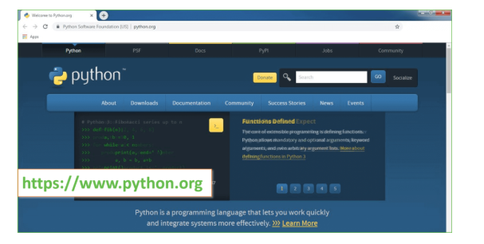
Now, check for the latest and the correct version for your operating system.
Step 2: Click on the Download Tab.
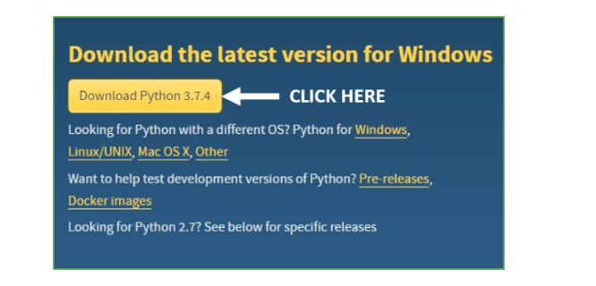
Step 3: You can either select the Download Python for windows 3.7.4 button in Yellow Color or you can scroll further down and click on download with respective to their version. Here, we are downloading the most recent python version for windows 3.7.4
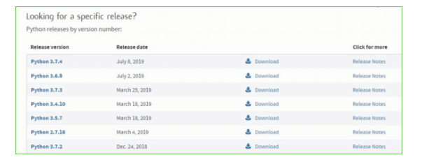
Step 4: Scroll down the page until you find the Files option.
Step 5: Here you see a different version of python along with the operating system.
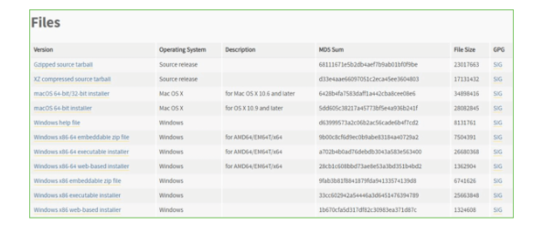

• To download Windows 32-bit python, you can select any one from the three options: Windows x86 embeddable zip file, Windows x86 executable installer or Windows x86 web-based installer.
• To download Windows 64-bit python, you can select any one from the three options: Windows x86-64 embeddable zip file, Windows x86-64 executable installer or Windows x86-64 web-based installer.
Here we will install Windows x86-64 web-based installer. Here your first part regarding which version of python is to be downloaded is completed. Now we move ahead with the second part in installing python i.e. Installation
Note: To know the changes or updates that are made in the version you can click on the Release Note Option.
Installation of Python
Step 1: Go to Download and Open the downloaded python version to carry out the installation process. 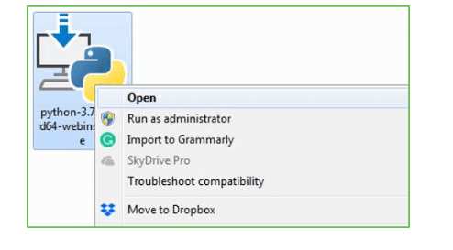
Step 2: Before you click on Install Now, Make sure to put a tick on Add Python 3.7 to PATH.
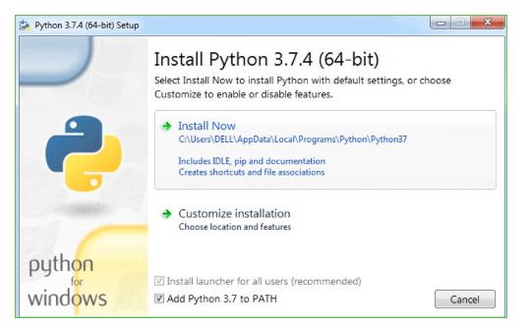
Step 3: Click on Install NOW After the installation is successful. Click on Close.
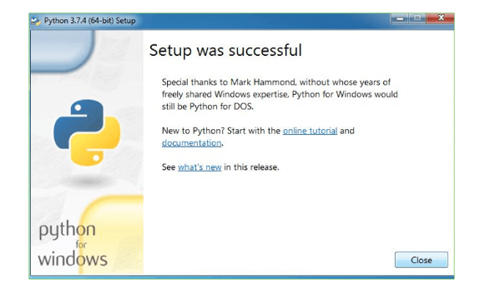
With these above three steps on python installation, you have successfully and correctly installed Python. Now is the time to verify the installation.
Note: The installation process might take a couple of minutes.
Verify the Python Installation
Step 1: Click on Start
Step 2: In the Windows Run Command, type “cmd”
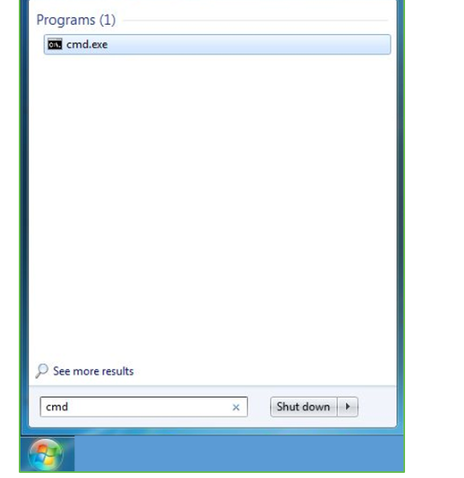
Step 3: Open the Command prompt option.
Step 4: Let us test whether the python is correctly installed. Type python –V and press Enter.
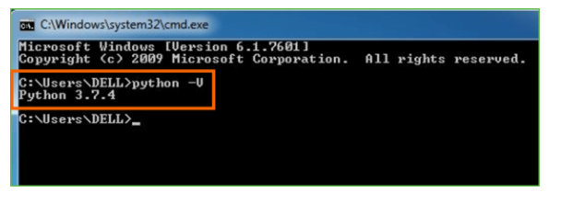

Step 5: You will get the answer as 3.7.4
Note: If you have any of the earlier versions of Python already installed. You must first uninstall the earlier version and then install the new one.
Check how the Python IDLE works
Step 1: Click on Start
Step 2: In the Windows Run command, type “python idle”
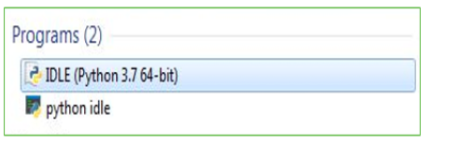
Step 3: Click on IDLE (Python 3.7 64-bit) and launch the program
Step 4: To go ahead with working in IDLE you must first save the file. Click on File > Click on Save
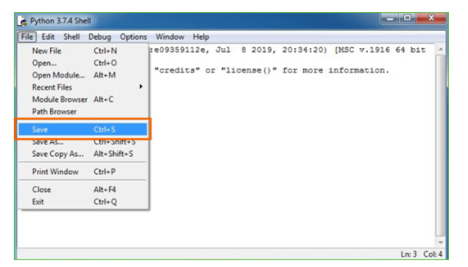
Step 5: Name the file and save as type should be Python files. Click on SAVE. Here I have named the files as Hey World.
Step 6: Now for e.g. enter print (“Hey World”) and Press Enter.
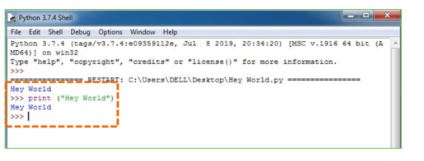
You will see that the command given is launched. With this, we end our tutorial on how to install Python. You have learned how to download python for windows into your respective operating system.
Note: Unlike Java, Python doesn’t need semicolons at the end of the statements otherwise it won’t work.
MACHINE LEARNING : -
Before we investigate the subtleties of different AI techniques, how about we start by seeing what AI is, and what it isn't. Although machine learning is frequently referred to as a subfield of artificial intelligence, I believe that categorization can frequently be initially misleading. The investigation of AI positively emerged from research in this specific circumstance, however in the information science use of AI techniques, it's more useful to consider AI for the purpose of building models of information.
In its most basic form, machine learning is the creation of mathematical models that aid in data comprehension. Learning" enters the conflict when we give these models tunable boundaries that can be adjusted to noticed information; The program can thus be regarded as "learning" from the data. These models can be used to predict and comprehend aspects of newly observed data once they have been fitted to data that has already been observed. The more philosophical discussion regarding the degree to which this kind of mathematical, model-based "learning" is comparable to the "learning" exhibited by the human brain will be left up to the reader. Understanding the issue setting in AI is crucial for utilizing these devices successfully, thus we will begin for certain general classifications of the kinds of approaches we'll examine here.
Classes Of Machine Inclining :-
Machine learning can be broken down into two main categories at the most fundamental level: learning under supervision and unsupervised learning.
Modeling the relationship between the data's measured features and some label is one aspect of supervised learning. New, unidentified data can be labeled with the help of this model once it has been established. Regression and classification tasks are two more subcategories of this: The labels in classification are discrete categories, whereas the labels in regression are continuous quantities. In the following section, we will see examples of both kinds of supervised learning.
Unsupervised learning is often referred to as "letting the dataset speak for itself," and it involves modeling the features of a dataset without using any labels. These models incorporate undertakings like bunching and dimensionality decrease. Bunching calculations distinguish unmistakable gatherings of information, while dimensionality decrease calculations look for additional brief portrayals of the information. In the following section, we will see examples of both kinds of unsupervised learning.
Need for AI
Individuals, as of now, are the most keen and high level species on earth since they can think, assess and tackle complex issues. On the opposite side, computer based intelligence is still in its underlying stage and haven't outperformed human knowledge in numerous viewpoints. Then the inquiry that is the need to make machine learn? The most appropriate justification behind doing this is, "to decide, in view of information, with proficiency and scale".

Recently, associations are putting vigorously in fresher advancements like Man-made brainpower, AI and Profound Figuring out how to get the critical data from information to play out a few true errands and tackle issues. We can call it information driven choices taken by machines, especially to mechanize the cycle. Problems that cannot naturally be programmed can benefit from these data-driven decisions rather than programming logic. The truth of the matter is that we can't manage without human insight, however other perspective is that we as a whole need to take care of genuine issues with proficiency at a gigantic scope. Because of this, machine learning is required..
.
Applications of Machines Learning :-
Researchers assert that we are in the golden age of AI and machine learning, with machine learning being the technology with the fastest growth rate. It is used to solve a lot of real-world complex problems that can't be solved using the traditional method. Emotion analysis, sentiment analysis, error detection and prevention, weather forecasting, stock market analysis and forecasting, speech synthesis, speech recognition, customer segmentation, object recognition, fraud detection and prevention, and product recommendation for online shoppers are just a few examples of ML's real-world applications. a) Terminologies of Machine Learning A model is a particular representation that is learned from data by using a machine learning algorithm. A model is likewise called a speculation.
• Highlight - A component is an individual quantifiable property of the information. A feature vector makes it simple to describe a collection of numerical features. The model receives input in the form of feature vectors. For instance, there may be characteristics like color, smell, taste, and so on that can be used to predict a fruit.
• Target (Label): The value that will be predicted by our model is referred to as a target variable or label. For the organic product model talked about in the component segment, the mark with each arrangement of information would be the name of the organic product like apple, orange, banana, and so on.
• Training: The idea is to provide a set of inputs (features) and expected outputs (labels), so that after training, a model (hypothesis) will map new data to one of the categories trained on.
• Prediction: When our model is ready, it can be given a set of inputs and a predicted output (a label) will be generated.
(b) Types of Machine Learning • Supervised Learning: This involves using classification and regression models to learn from a training dataset with labeled data. Until the required level of performance is reached, this learning process continues.
• Unsupervised Learning: Using factor and cluster analysis models, this method uses unlabeled data to learn more about the data itself by locating its underlying structure.
• Semi-supervised Learning: This method uses a small amount of labeled data and unlabeled data, similar to unsupervised learning. Utilizing named information tremendously expands the learning precision and is likewise more savvy than Managed Learning.
• Reinforcement Learning: This method entails figuring out the best course of action through trial and error. Learning behaviors that are based on the current state and will maximize reward in the future determine the subsequent action.

6.2 Packages and Versions
astunparse ==1.6.3
certifi ==2022.12.7
charset-normalizer ==3.0.1
contourpy ==1.0.7
cycler ==0.11.0
Django ==3.0.4
et-xmlfile ==1.1.0
fonttools ==4.38.0
gast ==0.3.3
google-pasta ==0.2.0
grpcio ==1.51.1
h5py ==2.10.0
idna ==3.4
importlib-metadata ==6.0.0
joblib ==1.2.0
Keras ==2.3.1
Keras-Applications ==1.0.8
Keras-Preprocessing ==1.1.2
kiwisolver ==1.4.4
Markdown ==3.4.1
matplotlib ==3.6.3
mysql-connector-python ==8.0.32
mysqlclient ==2.1.1
numpy ==1.21.4
oauthlib ==3.2.2
openpyxl ==3.1.0
opt-einsum ==3.3.0
packaging ==23.0
pandas ==1.3.5
Pillow ==9.4.0
pip ==20.1.1
protobuf ==3.20.3
pyparsing ==3.0.9
opencv-contrib-python 4.5.2.52

CHAPTER – 7
Dataset description:
In this project author is divided the project into two parts and in first part he gave brief literature on technologies which can be used to improve vineyard growth and in second part he describe ‘-ML Database’ which can be used to train various machine learning algorithms such as SVM, KNN, Logistic Regression and many more. Once we trained model on ML algorithms then that trained model can be used to predict grape growth, harvest time and phenology (development cycle) type on new test images.
In given database author has given five different types of dataset which describe below
- Dataset 1: This dataset can be used to train ML algorithms and this trained model can be used to predict harvest time
- Dataset 2: This dataset cab used to train ML algorithms which can be used to predict growth
- Dataset 3: This can be used to predict phenology stage.
- Dataset 4 and 5 can be used to predict maturity.
Note: In dataset there is no images for disease prediction so we cannot implement that module
Here in this project we are using first 3 dataset to predict harvest time, growth rate and phenology type and dataset 4 and 5 we are skipping as it’s taking too much long time for execution due to huge images and for same reason we have implemented only SVM algorithm.

SCREEN SHOTS

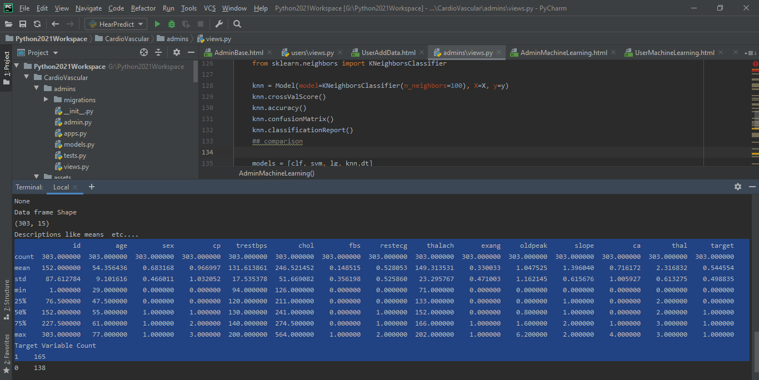
Correlation Matrix:

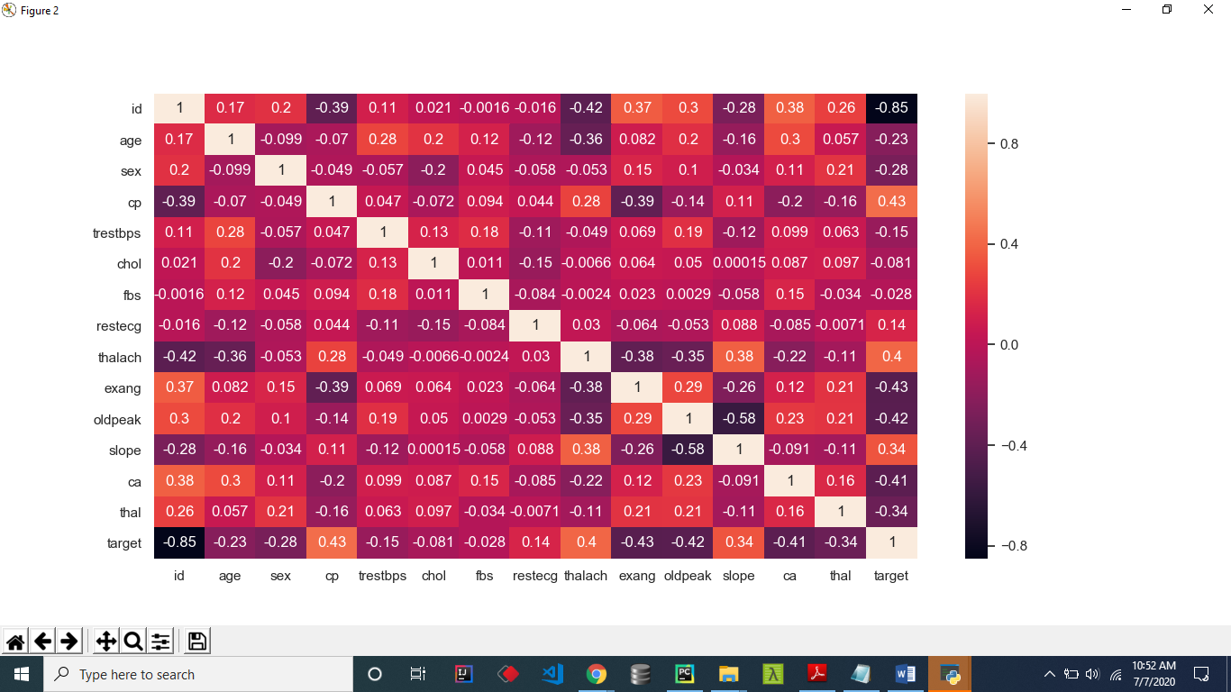

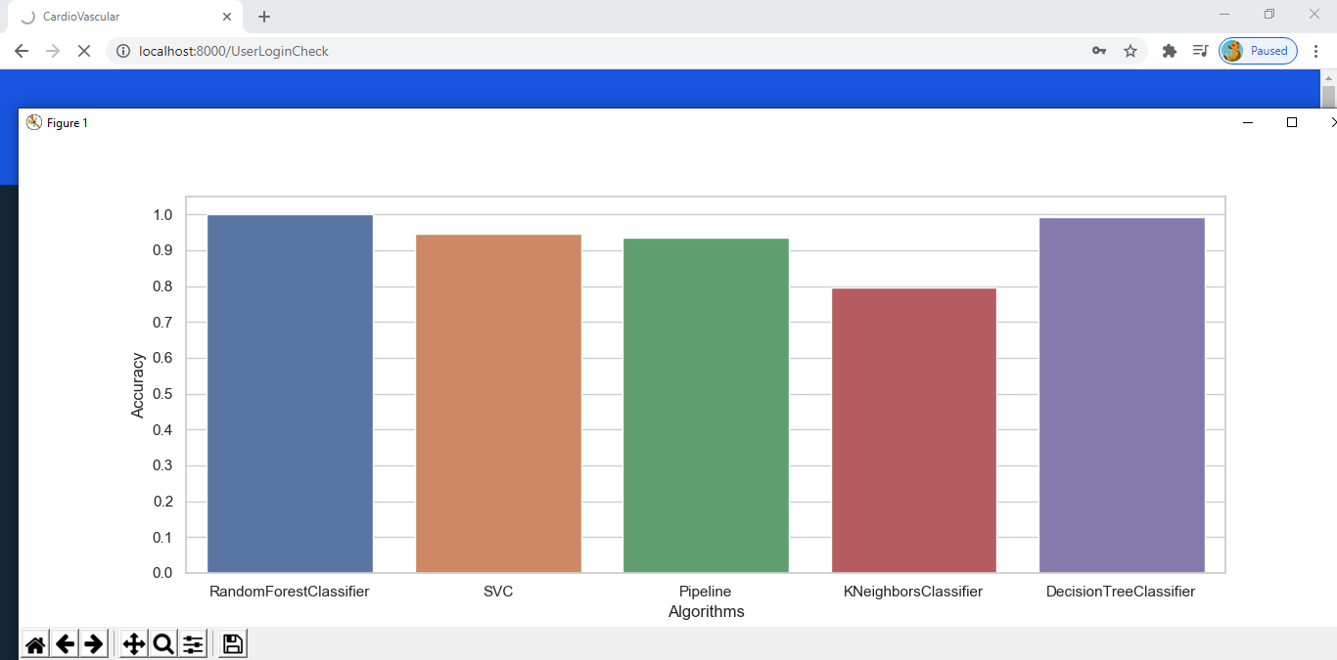

Accuracy on Client Side:
CHAPTER – 8
SYSTEM TESTING
The purpose of testing is to discover errors. Testing is the process of trying to discover every conceivable fault or weakness in a work product. It provides a way to check the functionality of components, sub assemblies, assemblies and/or a finished product It is the process of exercising software with the intent of ensuring that the Software system meets its requirements and user expectations and does not fail in an unacceptable miner. There are various types of test. Each test type addresses a specific testing requirement.

TYPES OF TESTS

Unit testing
Unit testing involves the design of test cases that validate that the internal program logic is functioning properly, and that program inputs produce valid outputs. All decision branches and internal code flow should be validated. It is the testing of individual software units of the application .it is done after the completion of an individual unit before integration. This is a structural testing, that relies on knowledge of its construction and is invasive. Unit tests perform basic tests at component level and test a specific business process, application, and/or system configuration. Unit tests ensure that each unique path of a business process performs accurately to the documented specifications and contains clearly defined inputs and expected results.

Integration testing
Integration tests are designed to test integrated software components to determine if they actually run as one program. Testing is event driven and is more concerned with the basic outcome of screens or fields. Integration tests demonstrate that although the components were individually satisfaction, as shown by successfully unit testing, the combination of components is correct and consistent. Integration testing is specifically aimed at exposing the problems that arise from the combination of components.

Functional test

Functional tests provide systematic demonstrations that functions tested are available as specified by the business and technical requirements, system documentation, and user manuals.
Functional testing is centered on the following items:
Valid Input : identified classes of valid input must be accepted.
Invalid Input : identified classes of invalid input must be rejected.
Functions : identified functions must be exercised.
Output : identified classes of application outputs must be exercised.
Systems/Procedures : interfacing systems or procedures must be invoked.
Organization and preparation of functional tests is focused on requirements, key functions, or special test cases. In addition, systematic coverage pertaining to identify Business process flows; data fields, predefined processes, and successive processes must be considered for testing. Before functional testing is complete, additional tests are identified and the effective value of current tests is determined.

System Test
System testing ensures that the entire integrated software system meets requirements. It tests a configuration to ensure known and predictable results. An example of system testing is the configuration oriented system integration test. System testing is based on process descriptions and flows, emphasizing pre-driven process links and integration points.

White Box Testing
White Box Testing is a testing in which in which the software tester has knowledge of the inner workings, structure and language of the software, or at least its purpose. It is purpose. It is used to test areas that cKNNot be reached from a black box level.

Black Box Testing

Black Box Testing is testing the software without any knowledge of the inner workings, structure or language of the module being tested. Black box tests, as most other kinds of tests, must be written from a definitive source document, such as specification or requirements document, such as specification or requirements document. It is a testing in which the software under test is treated, as a black box .you cKNNot “see” into it. The test provides inputs and responds to outputs without considering how the software works.
Unit Testing
Unit testing is usually conducted as part of a combined code and unit test phase of the software lifecycle, although it is not uncommon for coding and unit testing to be conducted as two distinct phases.
Test strategy and approach
Field testing will be performed manually and functional tests will be written in detail.
Test objectives
- All field entries must work properly.
- Pages must be activated from the identified link.
- The entry screen, messages and responses must not be delayed.

Features to be tested
- Verify that the entries are of the correct format
- No duplicate entries should be allowed
- All links should take the user to the correct page.

Integration Testing
Software integration testing is the incremental integration testing of two or more integrated software components on a single platform to produce failures caused by interface defects.
The task of the integration test is to check that components or software applications, e.g. components in a software system or – one step up – software applications at the company level – interact without error.
Test Results: All the test cases mentioned above passed successfully. No defects encountered.

Acceptance Testing
User Acceptance Testing is a critical phase of any project and requires significant participation by the end user. It also ensures that the system meets the functional requirements.
Test Results: All the test cases mentioned above passed successfully. No defects encountered.

TEST CASES:
S.no | Test Case | Excepted Result | Result
1 | User register | User register successfully | Pass
2 | User login | User login  successfully | Pass
3 | Add Data | Add Data  Successfully | Pass
4 | Data View | Data View Successfully | Pass
5 | Data Descriptions | Data Descriptions Successfully | Pass
6 | Correlation Matrix | Correlation Matrix Successfully | Pass
7 | Box plot | Box plot Successfully | Pass
8 | Heat Frequency graph | Successfully get  Heat Frequency graph | Pass
9 | Distribution on Age graph | Successfully get  Distribution on Age graph | Pass
10 | Calculated Frequency | Successfully get  Calculated Frequency | Pass
11 | Scatter matrix | Successfully get  Scatter matrix | Pass
12 | Age Wise Disease Scatter graph | Successfully get  Age Wise Disease Scatter graph | Pass
13 | Cleaned data | Successfully get  Cleaned data | Pass
14 | Random Forest Confusion matrix | Successfully get  Random Forest Confusion matrix | Pass
15 | Decision Tree  Confusion matrix | Successfully get  Decision Tree  Confusion matrix | Pass
16 | Random Forest Roc | Successfully get  Random Forest Roc | Pass
17 | SVC Curve | Successfully get  Successfully get | Pass
18 | Algorithm Accuracy | Algorithm Accuracy  Successfully | Pass

CHAPTER – 9
CONCLUSION AND FUTURE ENHANCEMENT
In this work, machine learning classifiers such as Random Forest, Decision Tree, Logistic Regression, Support vector machine (SVM), K-nearest neighbors (KNN) were used in the prediction of Cardio Vascular Disease (CVD). The proposed method using a random forest machine learning classifier has achieved a greater accuracy of 85.71% with a ROC AUC score of 0.8675 which outperformed all the classifiers under analysis in classifying patients with Cardio Vascular Disease.

Further Enhancement
The area under the ROC curve measures how well a continuous variable predicts the outcome of interest: if the sensitivity increases steeply as the threshold for diagnosis is relaxed with only a relatively slow accumulation of false positives, the area under the ROC curve will be large; conversely, if the sensitivity increases slowly as the threshold for diagnosis is relaxed with a rapid accumulation of false positives, the area under the ROC curve will be correspondingly smaller. The differences in areas may be tested to determine whether they are statistically significant. We have used this approach to compare the fasting glucose value and the value 2 h after an oral glucose load with various multivariate models for predicting future (Cardio Vascular Disease)CVD.
.

REFERENCES

[1] https://www.who.int/news-room/fact-sheets/detail/cardiovasculardiseases-(cvd)
[2] Kelly, B. B., & Fuster, V. (Eds.). (2010). Promoting cardiovascular health in the developing world: a critical challenge to achieve global health. National Academies Press.
[3] Poirier, Paul, et al. "Obesity and cardiovascular disease: pathophysiology, evaluation, and effect of weight loss: an update of the 1997 American Heart Association Scientific Statement on Obesity and Heart Disease from the Obesity Committee of the Council on Nutrition, Physical Activity, and Metabolism." Circulation 113.6 (2006): 898-918.
[4] Bhatnagar, Prachi, et al. "Trends in the epidemiology of cardiovascular disease in the UK." Heart 102.24 (2016): 1945-1952.
[5] Beunza, Juan-Jose, et al. "Comparison of machine learning algorithms for clinical event prediction (risk of coronary heart disease)." Journal of biomedical informatics 97 (2019): 103257.
[6] Zhao, Lina, et al. "Enhancing Detection Accuracy for Clinical Heart Failure Utilizing Pulse Transit Time Variability and Machine Learning." IEEE Access 7 (2019): 17716-17724.
[7] Borkar, Sneha, and M. N. Annadate. "Supervised Machine Learning Algorithm for Detection of Cardiac Disorders." 2018 Fourth International Conference on Computing Communication Control and Automation (ICCUBEA). IEEE, 2018.
[8] Omar Boursalie, Reza Samavi, Thomas E. Doyle. “M4CVD: Mobile Machine Learning Model for Monitoring Cardiovascular Disease.” Procedia Computer Science, 63 (2015): 384-391.
[9] Chen, Rui, et al. "Using Machine Learning to Predict One-year Cardiovascular Events in Patients with Severe Dilated Cardiomyopathy." European Journal of Radiology (2019).
[10] Dhar, Sanchayita, et al. "A Hybrid Machine Learning Approach for Prediction of Heart Diseases." 2018 4th International Conference on Computing Communication and Automation (ICCCA). IEEE, 2018.
[11] Dinesh, Kumar G., et al. "Prediction of Cardiovascular Disease Using Machine Learning Algorithms." 2018 International Conference on Current Trends towards Converging Technologies (ICCTCT). IEEE, 2018.
[12] Mezzatesta, Sabrina, et al. "A machine learning-based approach for predicting the outbreak of cardiovascular diseases in patients on dialysis." Computer Methods and Programs in Biomedicine 177 (2019): 9-15.
[13] Terrada, Oumaima, et al. "Classification and Prediction of atherosclerosis diseases using machine learning algorithms." 2019 5th International Conference on Optimization and Applications (ICOA). IEEE, 2019.
[14] Alić, Berina, Lejla Gurbeta, and Almir Badnjević. "Machine learning techniques for classification of diabetes and cardiovascular diseases." 2017 6th Mediterranean Conference on Embedded Computing (MECO). IEEE, 2017.
[15] Awan, Shahid Mehmood, Muhammad Usama Riaz, and Abdul Ghaffar Khan. "Prediction of heart disease using artificial neural network." VFAST Transactions on Software Engineering 13.3 (2018): 102-112.
[16] Fathalla, Karma M., et al. "Cardiovascular risk prediction based on Retinal Vessel Analysis using machine learning." 2016 IEEE International Conference on Systems, Man, and Cybernetics (SMC). IEEE, 2016.
[17] Gjoreski, Martin, et al. "Chronic Heart Failure Detection from Heart Sounds Using a Stack of Machine-Learning Classifiers." 2017 International Conference on Intelligent Environments (IE). IEEE, 2017.
[18] Metsker, Oleg, et al. "Dynamic mortality prediction using machine learning techniques for acute cardiovascular cases." Procedia Computer Science 136 (2018): 351-358.
[19] Balasubramanian, Vineeth Nallure, et al. "Support vector machine based conformal predictors for risk of complications following a coronary drug eluting stent procedure." 2009 36th Annual Computers in Cardiology Conference (CinC). IEEE, 2009.
[20] Groselj, C., et al. "Machine learning improves the accuracy of coronary artery disease diagnostic methods." Computers in Cardiology 1997. IEEE, 1997.

Sample Code
from django.shortcuts import render,HttpResponse
from django.contrib import messages
from users.models import UserRegistrationModel,HearDataModel
from django.core.paginator import Paginator, EmptyPage, PageNotAnInteger
from django.shortcuts import render, HttpResponse
from users.forms import UserRegistrationForm,HeartDataForm
# Create your views here.
from django.contrib import messages

from django_pandas.io import read_frame
import matplotlib.pyplot as plt
import seaborn as sns; sns.set()
from sklearn.preprocessing import StandardScaler

# Import tools
from sklearn.model_selection import train_test_split
from sklearn.model_selection import cross_val_score

from sklearn.metrics import accuracy_score, confusion_matrix, classification_report
from sklearn.metrics import roc_curve, auc
import numpy as np
import gc
# Create your views here.
def AdminLogin(request):
return render(request,'AdminLogin.html',{})

def AdminLoginCheck(request):
if request.method == 'POST':
usrid = request.POST.get('loginname')
pswd = request.POST.get('pswd')
print("User ID is = ", usrid)
if usrid == 'admin' and pswd == 'admin':
return render(request, 'admins/AdminHome.html')

else:
messages.success(request, 'Please Check Your Login Details')
return render(request, 'AdminLogin.html',{})
def RegisterUsersView(request):
data = UserRegistrationModel.objects.all()
return render(request,'admins/ViewRegisterUsers.html',{'data':data})

def ActivaUsers(request):
if request.method == 'GET':
id = request.GET.get('uid')
status = 'activated'
print("PID = ", id, status)
UserRegistrationModel.objects.filter(id=id).update(status=status)
data = UserRegistrationModel.objects.all()
return render(request,'admins/ViewRegisterUsers.html',{'data':data})
def AdminDataView(request):
data_list = HearDataModel.objects.all()
page = request.GET.get('page', 1)
paginator = Paginator(data_list, 15)
try:
data = paginator.page(page)
except PageNotAnInteger:
data = paginator.page(1)
except EmptyPage:
data = paginator.page(paginator.num_pages)
return render(request, 'admins/AdminDataView.html', {'data': data})

def AdminMachineLearning(request):
gc.collect()
qs = HearDataModel.objects.all()
df = read_frame(qs)
# Define our feasures and leabels
X = df.drop(['target'], axis=1).values
y = df['target'].values
scale = StandardScaler()
X = scale.fit_transform(X)
### Randome Forest Algorithm
from sklearn.ensemble import RandomForestClassifier
clf = Model(model=RandomForestClassifier(), X=X, y=y)
clf.crossValScore(cv=10)
clf.accuracy()
clf.confusionMatrix()
clf.classificationReport()
### Decesion Treee
from sklearn.tree import DecisionTreeClassifier
dt = Model(model=DecisionTreeClassifier(),X=X,y=y)
dt.crossValScore(cv=10)

dt.accuracy()
dt.confusionMatrix()
dt.classificationReport()
#SVM Algorithm
from sklearn.svm import SVC
svm = Model(model=SVC(C=5, probability=True), X=X, y=y)
svm.crossValScore(cv=10)
svm.accuracy()
svm.confusionMatrix()
svm.classificationReport()
## Pipe Line
import warnings
warnings.simplefilter("ignore")
from sklearn.linear_model import LogisticRegression
from sklearn.pipeline import make_pipeline
from sklearn.preprocessing import QuantileTransformer
lr = LogisticRegression()
pipeline = make_pipeline(QuantileTransformer(output_distribution='normal'), lr)
lg = Model(model=pipeline, X=X, y=y)
lg.crossValScore()
lg.accuracy()
lg.confusionMatrix()
lg.classificationReport()
### KNN Algorithm
from sklearn.neighbors import KNeighborsClassifier
knn = Model(model=KNeighborsClassifier(n_neighbors=100), X=X, y=y)
knn.crossValScore()
knn.accuracy()
knn.confusionMatrix()
knn.classificationReport()
## comparison
models = [clf, svm, lg, knn,dt]
for model in models[:2]:
model.rocCurve()
models = [clf, svm, lg, knn,dt]
for model in models[2:]:
model.rocCurve()
models = [clf, svm, lg, knn,dt]
names = []
accs = []
rsltdict = {}
for model in models:
accura = model.accuracy()
modelname = model.model_str()
accs.append(accura);
names.append(modelname);
rsltdict.update({modelname:accura})
sns.set_style("whitegrid")
plt.figure(figsize=(16, 5))
plt.yticks(np.arange(0, 1.2, 0.1))
plt.ylabel("Accuracy")
plt.xlabel("Algorithms")
sns.barplot(x=names, y=accs)
plt.savefig('models_accuracy.png')
plt.show()
#window.close()
layout = None
#window = None
gc.collect()
return render(request,'admins/AdminMachineLearning.html',{'rsltdict':rsltdict})
class Model:
def __init__(self, model, X, y):
self.model = model
self.X = X
self.y = y
self.X_train, self.X_test, self.y_train, self.y_test = train_test_split(self.X, self.y, test_size=0.5,
random_state=42)
self.model.fit(self.X_train, self.y_train)
print(f"{self.model_str()} Model Trained..")
self.y_pred = self.model.predict(self.X_test)
def model_str(self):
return str(self.model.__class__.__name__)
def crossValScore(self, cv=5):
print(self.model_str() + "\n" + "=" * 60)
scores = ["accuracy", "precision", "recall", "roc_auc"]
for score in scores:
cv_acc = cross_val_score(self.model,
self.X_train,
self.y_train,
cv=cv,
scoring=score).mean()
print("Model " + score + " : " + "%.3f" % cv_acc)

def accuracy(self):
accuarcy = accuracy_score(self.y_test, self.y_pred)
print(self.model_str() + " Model " + "Accuracy is: "+str(accuarcy))
return accuarcy
def confusionMatrix(self):
plt.figure(figsize=(5, 5))
mat = confusion_matrix(self.y_test, self.y_pred)
sns.heatmap(mat.T, square=True,
annot=True,
cbar=False,
xticklabels=["Haven't Disease", "Have Disease"],
yticklabels=["Haven't Disease", "Have Disease"])
plt.title(self.model_str() + " Confusion Matrix")
plt.xlabel('Predicted Values')
plt.ylabel('True Values');
plt.show();
def classificationReport(self):
print(self.model_str() + " Classification Report" + "\n" + "=" * 60)
print(classification_report(self.y_test,
self.y_pred,
target_names=['Non Disease', 'Disease']))
def rocCurve(self):
y_prob = self.model.predict_proba(self.X_test)[:, 1]
fpr, tpr, thr = roc_curve(self.y_test, y_prob)
lw = 2
plt.figure(figsize=(8, 6))
plt.plot(fpr, tpr,
color='darkorange',
lw=lw,
label="Curve Area = %0.3f" % auc(fpr, tpr))
plt.plot([0, 1], [0, 1], color='green',
lw=lw, linestyle='--')
plt.xlabel('False Positive Rate')
plt.ylabel('True Positive Rate')
plt.title(self.model_str() + ' Receiver Operating Characteristic Plot')
plt.legend(loc="lower right")
plt.show()

